E-commerce Platform Search Function
using System;

namespace ECommerceSearch
{
class Product
{
public int ProductId;
public string ProductName;
public string Category;

public Product(int id, string name, string category)
{
ProductId = id;
ProductName = name;
Category = category;
}
}

class Program
{
static Product LinearSearch(Product[] products, int id)
{
foreach (Product p in products)
{
if (p.ProductId == id)
return p;
}
return null;
}

static Product BinarySearch(Product[] products, int id)
{
int low = 0;
int high = products.Length - 1;

while (low <= high)
{
int mid = (low + high) / 2;

if (products[mid].ProductId == id)
return products[mid];

if (products[mid].ProductId < id)
low = mid + 1;
else
high = mid - 1;
}

return null;
}

static void Main(string[] args)
{
Product[] products =
{
new Product(101,"Laptop","Electronics"),
new Product(102,"Mobile","Electronics"),
new Product(103,"Headphones","Accessories"),
new Product(104,"Keyboard","Accessories"),
new Product(105,"Mouse","Accessories")
};

int searchId = 104;

Product result1 = LinearSearch(products, searchId);

if (result1 != null)
Console.WriteLine("Linear Search Found: " + result1.ProductName);

Product result2 = BinarySearch(products, searchId);

if (result2 != null)
Console.WriteLine("Binary Search Found: " + result2.ProductName);

Console.WriteLine("\nComplexity:");
Console.WriteLine("Linear Search = O(n)");
Console.WriteLine("Binary Search = O(log n)");
}
}
}

Output
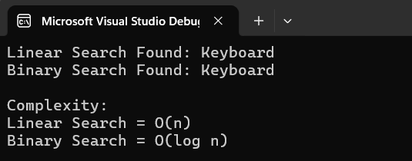

Analysis
Big O Notation

Big O notation is used to measure the efficiency of an algorithm. It helps us understand how the execution time of a program changes when the amount of data increases. It is useful for comparing different algorithms and selecting the most efficient one for a particular task.

Linear Search

In linear search, each element is checked one by one until the required product is found. If the product is present near the beginning of the list, the search takes less time. However, if the product is located at the end of the list or is not present, every element must be checked.

Best Case: O(1) – Product found at the first position.
Average Case: O(n) – Product found somewhere in the middle.
Worst Case: O(n) – Product found at the last position or not found.

Binary Search

Binary search works only on sorted data. It repeatedly divides the search space into two halves and compares the middle element with the target value. This significantly reduces the number of comparisons required.

Best Case: O(1) – Product found at the middle position in the first comparison.
Average Case: O(log n)
Worst Case: O(log n)

Comparison of Linear Search and Binary Search

Linear search is simple to implement and can be used on unsorted data. However, it becomes slower as the number of products increases. Binary search is much faster for large datasets because it eliminates half of the remaining elements in each step, but it requires the data to be sorted.

Conclusion

For a large e-commerce platform containing thousands of products, binary search is more suitable because it provides faster search performance and reduces the time required to find a product. Linear search is more appropriate for small datasets or when the product list is not sorted.

